Dear Patient:
Who can use the patient portal?
The eClinicalWorks Patient Portal is available to all patients and healthcare providers who use the eClinicalWorks electronic health record system. This includes patients of primary care physicians, specialists, hospitals, and other healthcare organizations.
Why should you use the patient portal?
There are many reasons why you should use the patient portal:
- Access your medical records 24/7: View your lab results, medications, immunizations, allergies, and other important health information at any time.
- Schedule appointments and request refills: Easily schedule appointments online and request prescription refills without calling your doctor’s office.
- Communicate with your healthcare providers: Send secure messages to your doctor or other healthcare providers and ask questions about your health.
- Pay your bills online: Pay your medical bills securely and conveniently online.
- Manage your family’s healthcare: Access the portal for your children and other family members to manage their health information.
- Stay informed about your health: Access educational materials and resources on a variety of health topics.
What features does the patient portal offer?
The eClinicalWorks Patient Portal offers a variety of features and resources, including:
- Medical record access: View your medical history, including lab results, medications, immunizations, allergies, and other important information.
- Appointment scheduling: Schedule appointments online 24/7.
- Prescription refills: Request prescription refills online without calling your doctor’s office.
- Secure messaging: Send and receive secure messages to your doctor or other healthcare providers.
- Bill Pay: Pay your medical bills online securely and conveniently.
- Health information: Access educational materials and resources on a variety of health topics.
- Family health management: Manage the health information of your children and other family members.
How do you use the patient portal and how to log into eClinicalWorks Patient Portal ?
To use the eClinicalWorks Patient Portal, you will need to create an account. You can do this by visiting your provider’s website or by clicking on the “Create Account” link on the eClinicalWorks Patient Portal website.
Once you have created an account, you will be able to log in and access all the features and resources that the portal has to offer. Here are the step-by-step instructions on how to log in:

- Go to the eClinicalWorks Patient Portal website. https://healow.com/apps/jsp/webview/index.jsp
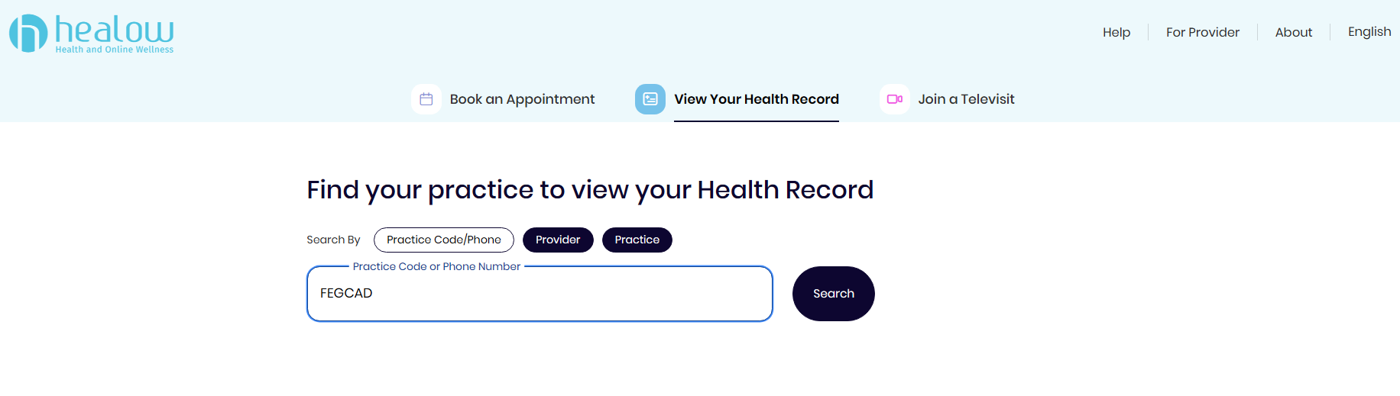
- You can access the portal by clicking here or by typing the following URL into your web browser:
https://mycw90.ecwcloud.com/portal12105/jsp/100mp/login_otp.jsp

CODE FOR PRACTICE: FEGCAD
- Enter your login credentials
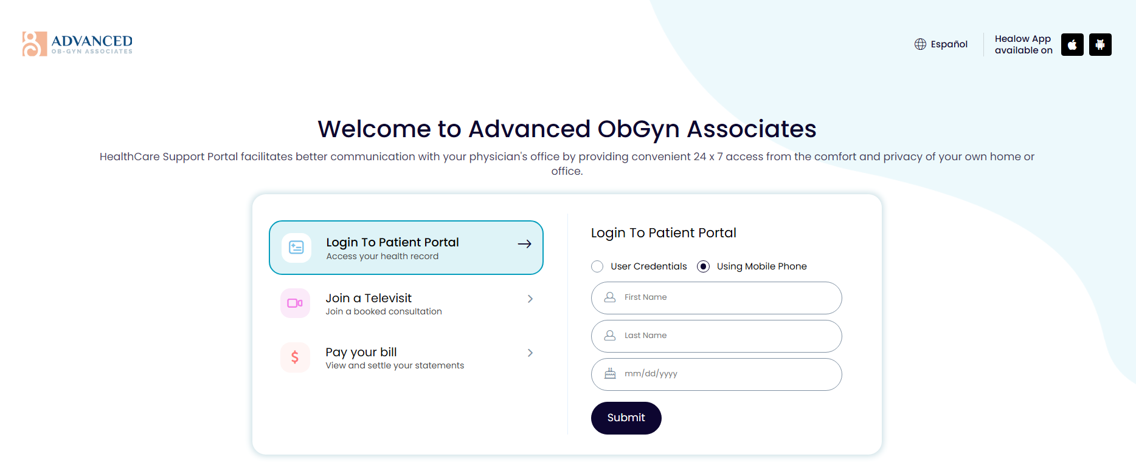
- Review the security information.
The first time you log in, you will be prompted to review the website’s security information. Please read this information carefully and click on the “Accept” button to proceed.
*Here are some additional tips for logging into the eClinicalWorks Patient Portal:
- Make sure your web browser is up to date.
- Use a strong password and keep it confidential.
- Do not share your login credentials with anyone.
- If you forget your password, you can click on the “Forgot Password?” link on the login page.
- If you have any problems logging in, please contact your healthcare provider’s office for assistance.

